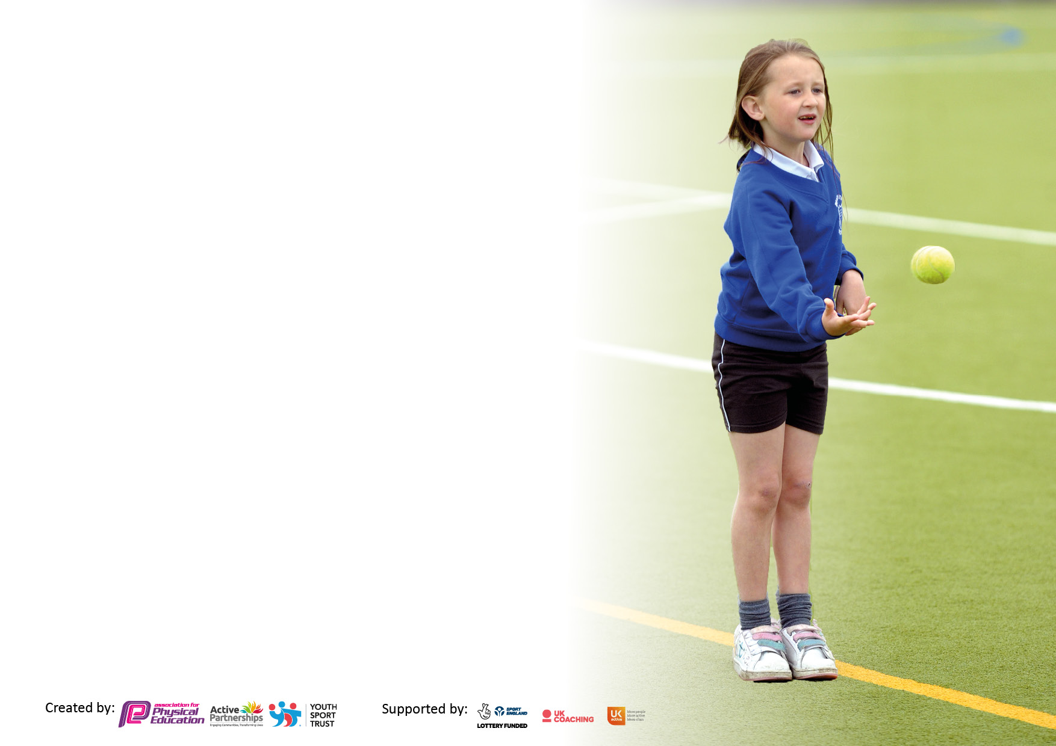

It is important that your grant is used effectively and based on school need. The Education Inspection Framework makes clear there will be a focus on **‘whether leaders and those responsible for governors all understand their respective roles and perform these in a way that enhances the effectiveness of the school’**.

Under the Quality of Education Ofsted inspectors consider:

**Intent** - Curriculum design, coverage and appropriateness

**Implementation** - Curriculum delivery, Teaching (pedagogy) and Assessment

**Impact** - Attainment and progress

To assist schools with common transferable language this template has been developed to utilise the same three headings which should make your plans easily transferable between working documents.

Schools must use the funding to make **additional and sustainable** improvements to the quality of Physical Education, School Sport and Physical Activity (PESSPA) they offer. This means that you should use the Primary PE and sport premium to:

* Develop or add to the PESSPA activities that your school already offer
* Build capacity and capability within the school to ensure that improvements made now will benefit pupils joining the school in future years
* The Primary PE and sport premium should not be used to fund capital spend projects; the school’s budget should fund these.

Pleasevisitgov.ukfortherevisedDfEguidanceincludingthe5keyindicatorsacrosswhichschoolsshoulddemonstrate animprovement.Thisdocumentwillhelpyoutoreviewyourprovisionandtoreportyourspend.DfEencouragesschools to use this template as an effective way of meeting the reporting requirements of the Primary PE and Sport Premium.

We recommend you start by reflecting on the impact of current provision and reviewing the previous spend.

Schools are required to publish details of how they spend this funding, including any under-spend from 2021/2022, as well as on the impact it has on pupils’ PE and sport participation and attainment. **All funding must be spent by 31st July 2023.**

We recommend regularly updating the table and publishing it on your website throughout the year. This evidences your ongoing self-evaluation of how you are using the funding to secure maximum, sustainable impact. Final copy must be posted on your website by the end of the academic year and no later than the 31st July 2023. To see an example of how to complete the table please click HERE.

**Details with regard to funding**

Please complete the table below.

|  |  |
| --- | --- |
| Total amount carried over from 2021/22 | £0 |
| Total amount allocated for 2021/22 | £17,330 |
| How much (if any) do you intend to carry over from this total fund into 2022/23? | £0 |
| Total amount allocated for 2022/23 | £17,980 |
| Total amount of funding for 2023/23. To be spent and reported on by 31st July 2023. | £17,980 |

**Swimming Data**

Please report on your Swimming Data below.

|  |  |
| --- | --- |
| Meeting national curriculum requirements for swimming and water safety.  N.B. Complete this section to your best ability. For example you might have practised safe self-rescue techniques on dry land which you can then transfer to the pool when school swimming restarts.  **Due to exceptional circumstances priority should be given to ensuring that pupils can perform safe self rescue even if they do not fully meet the first two requirements of the NC programme of study** | NA  No Year 6 pupils currently. |
| What percentage of your current Year 6 cohort swim competently, confidently and proficiently over a distance of at least 25 metres?  **N.B.** Even though your pupils may swim in another year please report on their attainment on leaving primary school at the end of the summer term 2022.  Please see note above | NA |
| What percentage of your current Year 6 cohort use a range of strokes effectively [for example, front crawl, backstroke and breaststroke]?  Please see note above | NA |
| **What percentage of your current Year 6 cohort perform safe self-rescue in different water-based situations?** | NA |
| Schools can choose to use the Primary PE and sport premium to provide additional provision for swimming but this must be for activity **over and above** the national curriculum requirements. Have you used it in this way? | No |

**Action Plan and Budget Tracking**

Capture your intended annual spend against the 5 key indicators. Clarify the success criteria and evidence of impact that you intend to measure to evaluate for pupils today and for the future.

|  |  |  |  |  |
| --- | --- | --- | --- | --- |
| **Academic Year:** 2022/23 | **Total fund allocated:** £17,980 | **Date Updated:** 24/07/2023 | |  |
| **Key indicator 1:** The engagement of all pupils in regular physical activity – Chief Medical Officers guidelines recommend that primary school pupils undertake at least 30 minutes of physical activity a day in school | | | | Percentage of total allocation: |
| 22.4 % |
| **Intent** | **Implementation** | | **Impact** |  |
| **Your school focus should be clear what you want the pupils to know and be able to do and about**  **what they need to learn and to**  **consolidate through practice:** | **Make sure your actions to achieve are linked to your intentions:** | **Funding allocated: £4021** | **Evidence of impact: what do pupils now know and what can they now do? What has changed?:** | **Sustainability and suggested next steps:** |
| To encourage more physical activity during break times and lunchtimes as well as within lesson time  Creation of zones throughout the school ground, for the children to access freely and cater for the different needs, abilities and activity level of the children | Purchase of playground equipment  Purchase of sports equipment related to PE lessons  Sports coaches run activities at lunchtime to include dance and football. | £1006  £3015  Allocated in costs for specialists in key indicator 3 | Improved resources to engage the children and encourage participation.  Pupils will be more engaged at playtimes and lunchtimes  More children being active at lunchtime with a greater variety of activities provided.  Encourage wider participation of out of school sports clubs that is inspired by the activities in school. | As the school grows to full capacity, consider purchasing equipment to engage older KS2 pupils  Older KS2 pupils are taking on responsibility to run activities at lunchtime for Foundation and Y1 pupils. Further play leader training would further develop this. |
| **Key indicator 2:** The profile of PESSPA being raised across the school as a tool for whole school improvement | | | | Percentage of total allocation: |
| 19.7 % |
| **Intent** | **Implementation** | | **Impact** |  |
| **Your school focus should be clear what you want the pupils to know and be able to do and about**  **what they need to learn and to**  **consolidate through practice:** | **Make sure your actions to achieve are linked to your intentions:** | **Funding allocated:£3539** | **Evidence of impact: what do pupils now know and what can they now do? What has changed?:** | **Sustainability and suggested next steps:** |
| Spaces in the school will be maximised to allowed physical and sporting opportunities in a variety of ways. | Play resources being easily accessible to play leaders, designated football area with football coaches, dance zone, scooters and basketball zones.  New ‘Ninja Warrior’ style play equipment to be installed July 2023 to encourage more physical activity across the school | £Basketball zone paid for PTFA.  SEE playground equipment spend in KI1  Football coach: £275  Dance teacher in KI3.  £3264 play equipment. | All children have access to their resources which has increase physical activity at break and lunchtime. |  |

|  |  |  |  |  |
| --- | --- | --- | --- | --- |
| **Key indicator 3:** Increased confidence, knowledge and skills of all staff in teaching PE and sport | | | | Percentage of total allocation: |
| 56.2 % |
| **Intent** | **Implementation** | | **Impact** |  |
| **Your school focus should be clear** | **Make sure your actions to** | **Funding** | **Evidence of impact: what do** | **Sustainability and suggested** |
| **what you want the pupils to know** | **achieve are linked to your** | **allocated: £10,105** | **pupils now know and what** | **next steps:** |
| **and be able to do and about** | **intentions:** |  | **can they now do? What has** |  |
| **what they need to learn and to** |  |  | **changed?:** |  |
| **consolidate through practice:** |  |  |  |  |
| Teaching and learning in the PE curriculum areas is high quality and will increase staff confidence and knowledge and skills and improve outcomes for all pupils.  The continuation of the sports scheme and sports coaches to deliver high quality PE to support the intent as above. | Sports coach working alongside staff to develop CPD and delivery of high quality PE and sporting activities.  Dance coach working alongside staff to develop dance and confidence in teaching. | £6335  £3770 | Children will make good or better progress in lessons and over time.  Staff working more confidently with targeted groups of pupils to ensure appropriate challenge.  Staff to better understand invasion game skills, strategy and team work.  Dance supports PSHE curriculum through encouraging children to express emotions within a story context. | PE lead to network with other colleagues in other schools within the academy to encourage on going sharing of good practice, planning and assessment.  PE lead to monitor and provide support as appropriate in order to ensure progress and achievement are maintained by all pupils.  PE lead and headteacher to monitor impact of these sessions |
| **Key indicator 4:** Broader experience of a range of sports and activities offered to all pupils | | | | Percentage of total allocation: |
|  |
| **Intent** | **Implementation** | | **Impact** |  |
| **Your school focus should be clear** | **Make sure your actions to** | **Funding** | **Evidence of impact: what do** | **Sustainability and suggested** |
| **what you want the pupils to know** | **achieve are linked to your** | **allocated:** | **pupils now know and what** | **next steps:** |
| **and be able to do and about** | **intentions:** |  | **can they now do? What has** |  |
| **what they need to learn and to** |  |  | **changed?:** |  |
| **consolidate through practice:** |  |  |  |  |
| Additional achievements:  Enable a broader range of sports to be offered through affective timetabling.  Offer a range of cross-curricular activities to encourage active participation outside of school. | To continue lunchtime sporting clubs for KS1 to experience and opportunity across the school.  Buy equipment that allows a range of extra-curricular activities to be taught  Celebrate children’s sporting achievements outside of school. | £ See KI1 and KI3 for staffing and equipment. | Uptake of parent funded afterschool sports clubs increase dramatically such as running, football, multiskills and gardening clubs.  Dance and football clubs at lunchtime have a high uptake.  Significant increase in children wanting to share their sporting activities. | Consider further range of activities to encourage physical activity such a gymnastics, rugby, archery. |

|  |  |  |  |  |
| --- | --- | --- | --- | --- |
| **Key indicator 5:** Increased participation in competitive sport | | | | Percentage of total allocation: |
| 1.8 % |
| **Intent** | **Implementation** | | **Impact** |  |
| **Your school focus should be clear** | **Make sure your actions to** | **Funding** | **Evidence of impact: what do** | **Sustainability and suggested** |
| **what you want the pupils to know** | **achieve are linked to your** | **allocated:** | **pupils now know and what** | **next steps:** |
| **and be able to do and about** | **intentions:** |  | **can they now do? What has** |  |
| **what they need to learn and to** |  |  | **changed?** |  |
| **consolidate through practice:** |  |  |  |  |
| To enable more pupils to participate in school competitions and fixtures across a broader range of sports including sports days and after school clubs | Inter school tournaments for football. Give children opportunities to competitive strive to achieve using incentives such as stickers and house points. | £265  £50 | Children more engaged in school time sporting activities and encouraging those less confidence pupils and children not participating in tournaments. | Participate in local competitions in a variety of sports e,.g netball when school has grown to near capacity and includes Y6 pupils. |

|  |  |
| --- | --- |
| Signed off by | |
| Head Teacher: | Owen Wilder |
| Date: | 24/07/2023 |
| Subject Leader: | Sarah Newell |
| Date | 24/07/2023 |